The Vaquero Uniform

Learn how the vaquero work generated different types of equipment, clothing, and tools, adapted to the specifics of the environment and conditions. Often defined by what he wears, the vaquero dons the sombrero, botas, and chaparraras necessary to his line of work. Now you will learn and understand the terms of the vaquero’s uniform.
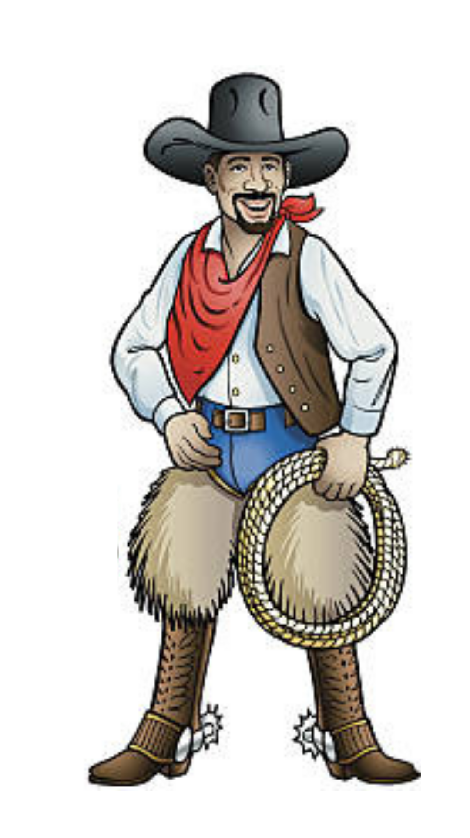

2.____________________

5.______________________ ____
4._____________________

3.______________________

1.________________________
8._______________________

6.____________________________
7.________________________

Fill in the blanks near the numbers on the vaquero Image. Choose which term belongs on the vaquero’s uniform.

Cowboy Uniform Terms:
- Lazo
- Camisa
- Bandanna
- Espuelas
- Botas
- Sombrero
- Chaleco vaquero
- Chaparreras

