Make Your Own Mission
In this activity we’ll be looking at the San Antonio Missions as a community, talk about what makes a community, and at the end you’ll have instructions to make your own mission!
Intro
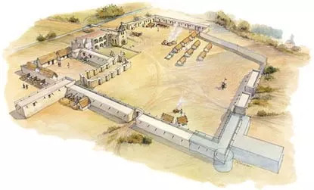
The San Antonio Colonial Missions were established in the early 1700’s as the Spanish Empire expanded their territory in “New Spain.” The missions were built on land occupied by many diverse Native American tribes, some of which had travelled to South Texas after being pushed out of their homes in the north by other colonial powers.
Mission structures housed entire communities along the San Antonio River. NPS Photo.

The Colonial Missions transformed local ways of life by introducing a new religion, farming, and settled communities. Native Americans were invited to live in the missions where they would be educated and receive protection and housing, in exchange for their work and labor to support the Spanish settlers. The church was the focal point of the mission, and soldiers lived in the missions to protect the land and people living inside it. Native Americans would work to construct the mission, farm, hunt, and make clothes to be worn and sold as goods.
Resources
https://www.nps.gov/saan/learn/historyculture/index.htm
https://www.thestoryoftexas.com/discover/campfire-stories/native-americans

Parts
In the space below, list all the parts of a colonial mission. These could be inside or outside the mission, as long as they are connected to the physical mission. Think about the buildings, tools, and equipment needed.

People
In the space below, list all of the people connected to the missions. Think about all the people needed for the different jobs, or the different Native American tribes that would have lived in the missions.

Interactions
Pick a few parts and a few people. In the space below, write how the parts and people would work together.

Community
Below is an excerpt of author Suzanne Goldsmith’s definition of a community:
“Communities are not built of friends, or of groups with similar styles and tastes, or even of people who like and understand each other. They are built of people who feel they are part of something that is bigger than themselves: a shared goal or enterprise, like righting a wrong, or building a road, or raising children, or living honorably, or worshipping a god. To build community requires only the ability to see value in others, to look at them and see a potential partner in one’s enterprise.”
Do you think this definition of a community represents the San Antonio missions? Why or why not?

How would you define “community” in your own words?

Below are the 6 essential components that a community needs to survive:
Housing | Where people live
Entertainment | How people have fun
Transportation | How people fun
Commerce | Where people buy/sell things
Education | Where people learn
Healthcare | Where people go when they’re sick

Can you identify all these components in the San Antonio Missions? What would they be?
Make Your Own Mission
Now that you have an idea of all the parts of a mission, the people who lived in the missions, how they worked together, and the essential components of a community, it’s time for you to make your own Mission!
Below is a list of materials and supplies you’ll need to start building, but try to use recyclable or found natural material! Start with a base, it can be whatever size you’d like.
Scissors
Tape, Glue
Cardboard-toilet paper and paper towel tubes
Food Packaging
Leaves
Sticks, twigs, or branches
Plastic bottles and bottle caps
Shredded material
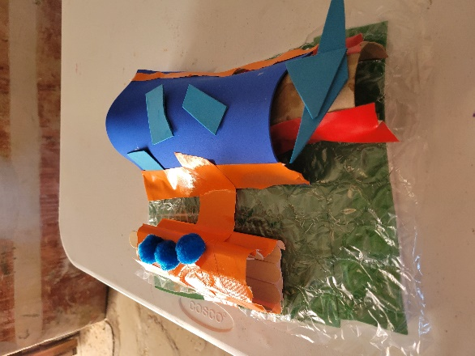
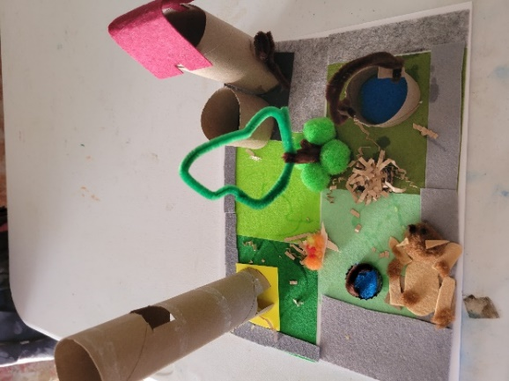
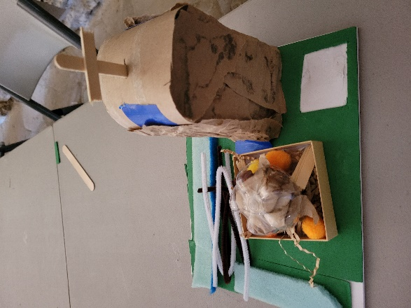

Sources
https://www.nps.gov/saan/learn/historyculture/index.htm
http://www.pz.harvard.edu/resources/parts-people-interactions
https://www.facinghistory.org/resource-library/identity-and-community/what-community

