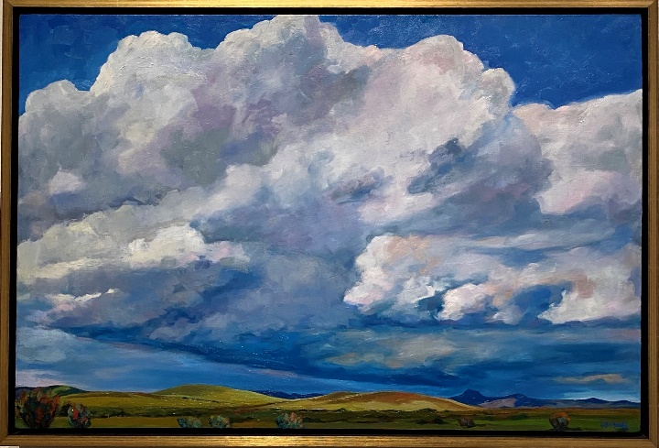

**3-D Cloud**

**Landscape**

*Solo Cloud,* Caroline Korbell Carrington, Oil on Canvas

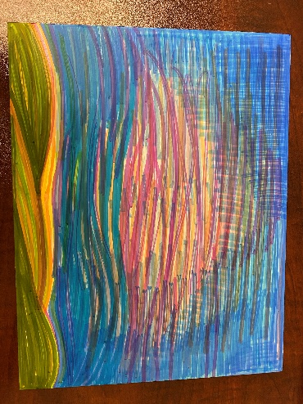Have you ever looked up to the sky and noticed just how amazing clouds are? They can change colors, create beautiful formations, and you can play I-Spy while watching them! In Western Art, clouds are just as much a part of the landscape as the animals and plants are. Many artists are known for the impressive way that they portray clouds in their art. Using inspiration from the painting *Solo Cloud*, create your own landscape featuring a big, fluffy cloud:

**Supplies needed:**

Cardstock or matboard

Fluff (pillow stuffing, felt, etc.)

Glue

Paint or markers

**Step 1:** Create a background. This can be as simple or complicated as you like. I used markers to create a colorful landscape scene, complete with a sunset and rolling hills.

**Step 2:** Attach the fluff or felt to the sky portion of your landscape by using a generous amount of glue over the areas where you want clouds. Then attach the material by pressing it down firmly onto the glue.

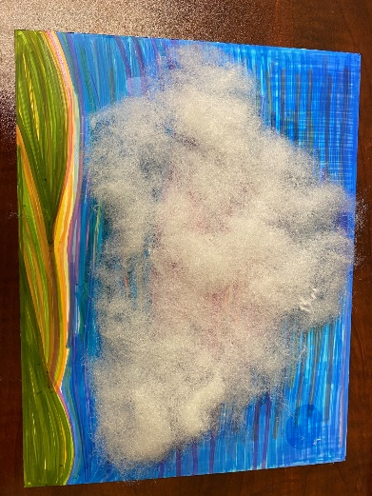

**Step 3:** (Optional) Add any additional details to your landscape such as windmills, animals, plants, or houses.

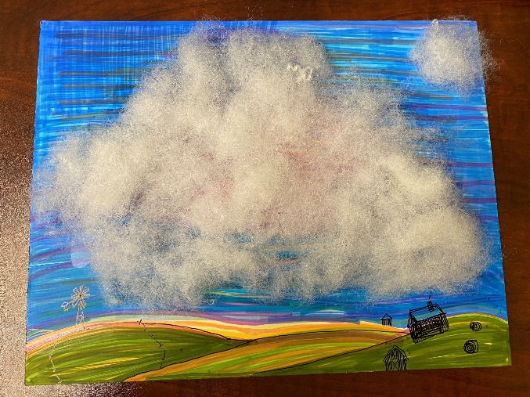

Be sure to tag **@BriscoeMuseum** and use the hashtags **#BeyondTheBriscoe** and **#TheWestStartsHere** so we can check out your fluffy clouds!