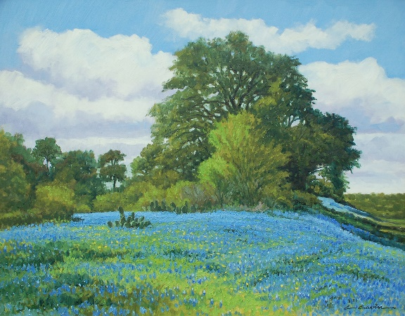
Drawing
Texas Bluebonnets

Hillside Blues by Cliff Cavin

When you close your eyes and think of Texas, what's the first thing that comes to mind? Is it the image of the rugged cowboy riding his horse out on the open range? Maybe you see a tumbleweed rolling in the wind or a field of bluebonnets. Texas is a pretty special place, not to mention it can be picture-perfect in the spring. Many Texas artists, such as those featured in the Janey Briscoe Marmion Collection at the Briscoe, draw inspiration from the bluebonnet for that very reason.
Have you seen a bluebonnet? Maybe at a park or along the side of the road? Think about the beautiful state flower and use these steps to create a Texas bluebonnet painting.

Step 1: Gather your materials

- Blue colored pencil
- Green colored pencil
- White colored pencil
- Paper to draw on
- Pencil sharpener

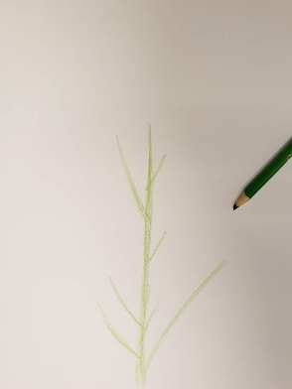

Step 2: Stems and Leaves
- With a light hand, pull up a line from the bottom of the page to create the main stem.
- Make smaller pencil strokes for the side shoots. There's no need to be perfect—you will cover much of these with the bluebonnets.

Step 3: Bluebonnet Blossoms
- Switch to the blue colored pencil. Begin adding your buds to the stems. To create the bud shape.
- Fill in more buds as needed. Remember, less is more, so start with a few, step back and look at your flower, and add buds where they are needed. Adding is easy, but subtracting is more difficult.
- Remember, no two flowers look the same, so embrace this in your flower drawing.
- Keeping adding petals until you like it, but don’t add too many.
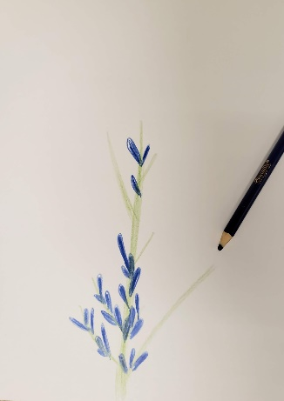
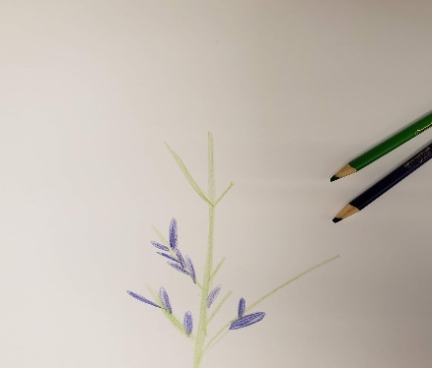

Step 4: Adding more detail
- Switch to the white color pencil.
- Add white colored pencil to your blue buds and at the top. On the example image, green colored pencil was added to create the illusion of a white tip.

