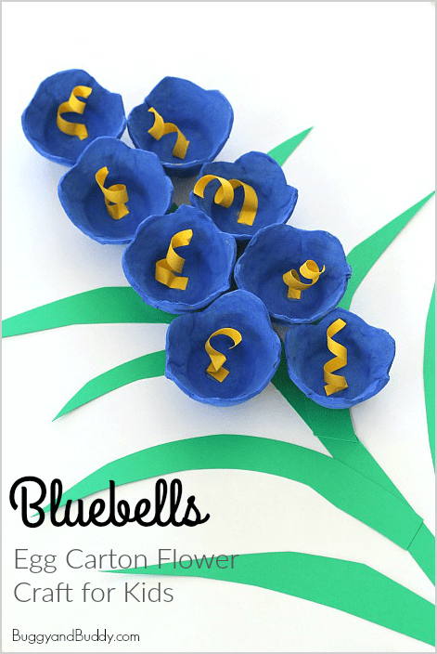
Materials for Egg Carton Flowers
- Empty egg carton
- Scissors
- Tempera paint and paintbrush
- Yellow and green construction paper
https://buggyandbuddy.com/bluebells-egg-carton-flower-craft/

Directions
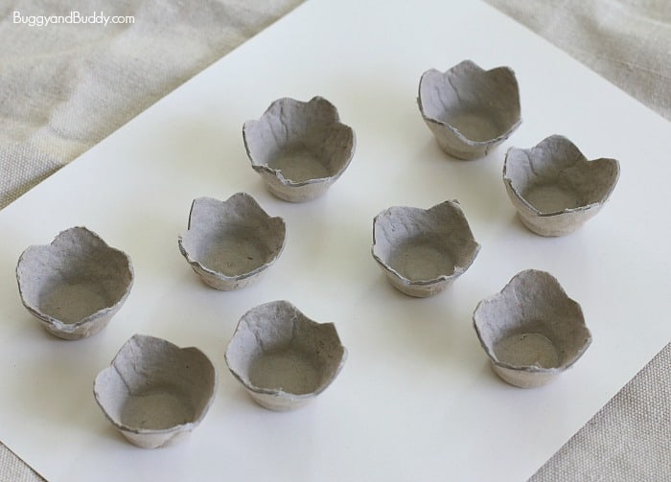
- Cut your egg carton apart into segments. Trim the edges to make them smooth and wavy.

- Paint your egg carton pieces the color of bluebells. (We mixed some turquoise and violet to make our final color.) Let the paint dry completely.
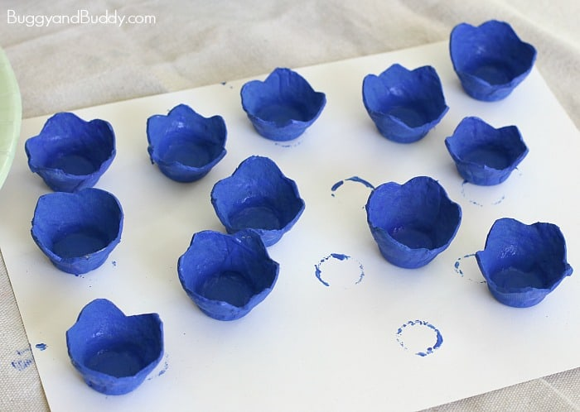

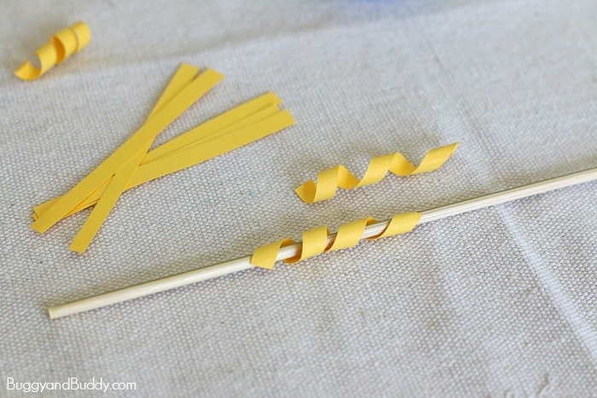
- To make the centers of the flowers, cut some thin strips of yellow construction paper. Wrap them around a pencil or other round item to make them spiral shaped.

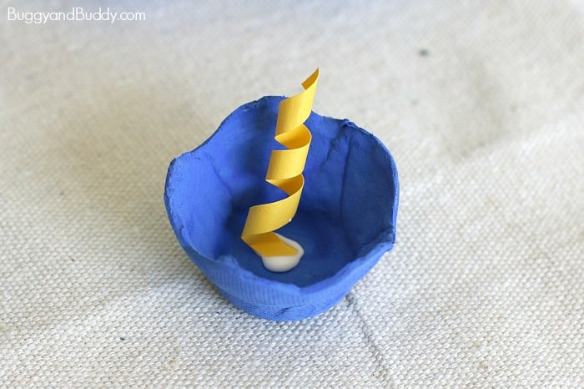
- Glue the yellow spiral to the center of the flower.

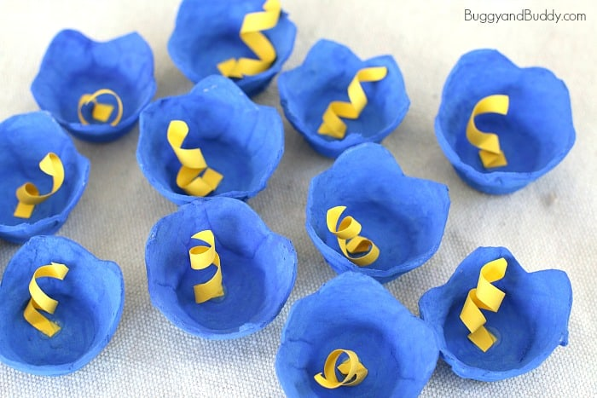
- Once the glue has dried, you can trim the yellow centers to the correct height and manipulate them a bit to get them to look the way you want.

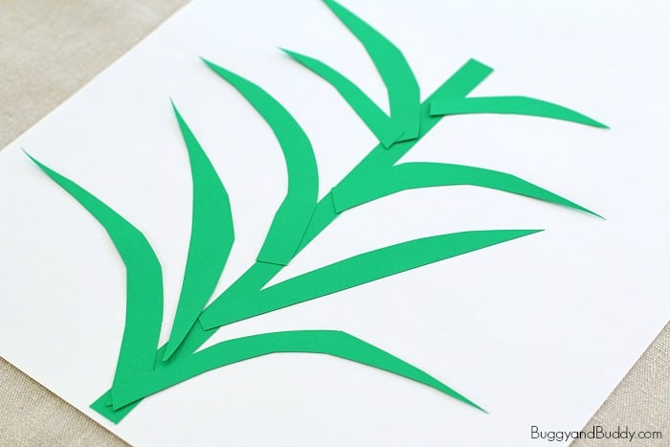
- Cut out a green stem and some green leaves from your green construction paper and glue them onto your paper.

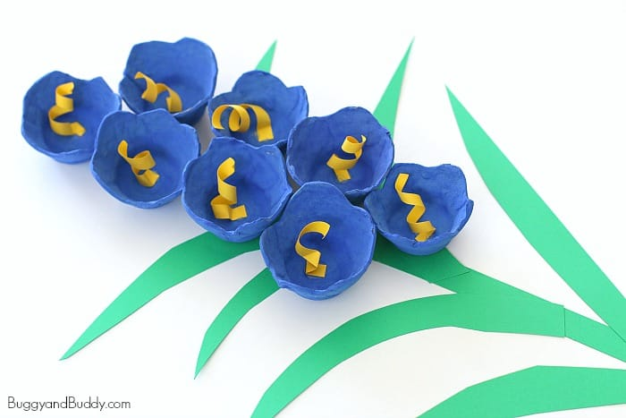
- Glue your flowers on the stem and leaves and let dry.

