Moon Phases Activity
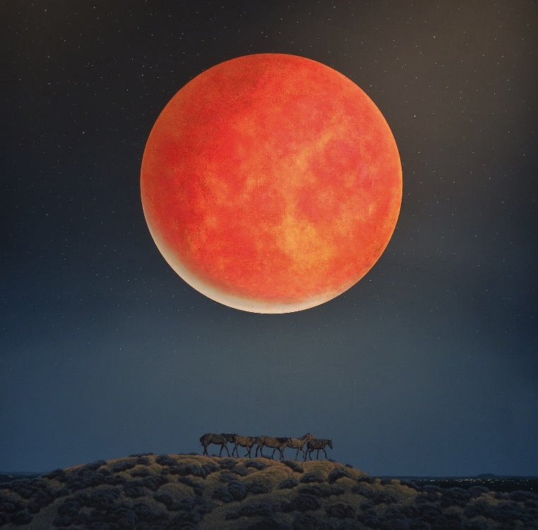
The moon is one of the most fascinating and studied objects in our night sky. It has been subject to numerous astronaut missions and scientific investigations. It is also responsible for our planets tidal waves! We will be learning about the moon on June 18th during our monthly “Full STEAM Ahead” series where families will create their own fizzy moon paintings.
Enjoy this family activity which explores the different phases of the moon. As the moon orbits around the Earth, sunlight will illuminate different shapes on the moon surface, causing the different shapes of the moon that we see at night.
Phil Epp, Red Moon. Acrylic on canvas.
MATERIALS/SUPPLIES
Black Construction Paper (x2)
White tempura paint
Paintbrush
Picture of the moon
Tape
Scissors

INSTRUCTIONS
Find a picture of the moon and cut it out. This can be from Google, a magazine, etc.
On your first piece of black construction paper, cut a circle that is roughly the same size of your moon picture.
Dip your paintbrush in the white paint, and flick the paint onto the construction paper. These will be the stars we see alongside the moon in the night sky.
Place the picture of the moon on the back of the black construction paper. On the backside, tape the top and bottom of the moon picture.
FRONT
BACK
With scissors, cut the edge of the second piece of black construction paper to create a curved edge.
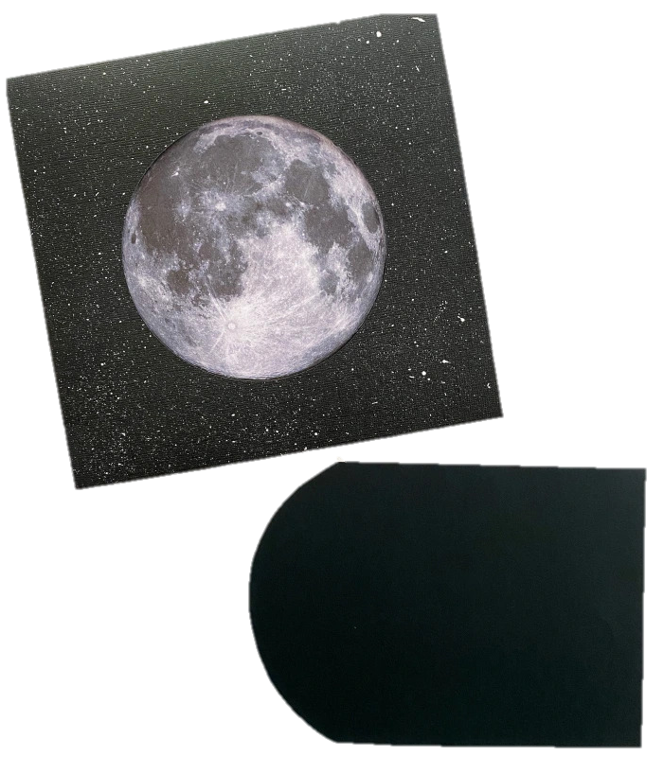
Insert the curved edge in between the moon and the painted construction paper. This will create the various shapes we see during the different phases of the moon.
Pictures and original activity: Phases of the Moon for Kids (cintaandco.com).
Additional activities: 15 Mesmerizing Moon Crafts for Kids (artsycraftsymom.com).

