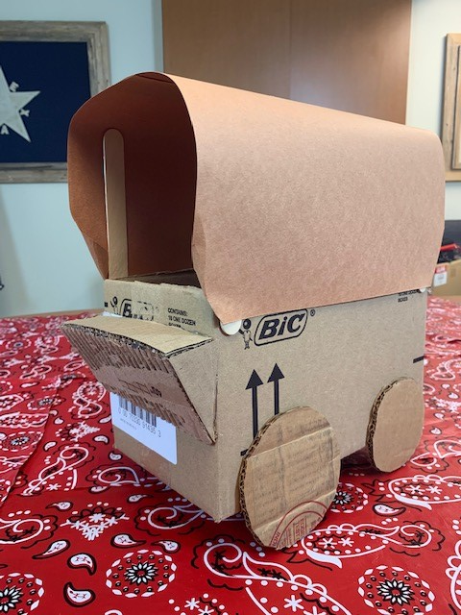
Make Your Own Chuckwagon:
The Chuckwagon was the center of life on the cattle drive. It was a place for storytelling, singing songs, and of course eating. After a long, hard day of work in the saddle, sometimes all a cowboy had to look forward to was heading to the Chuckwagon at the end of the day. The cook, often called “Cookie” was respected by all, as he arguably had the hardest job on the cattle drive, traveling ahead of the bunch to get started on the next meal. Here’s how you can make your own Chuckwagon:

Supplies Needed:
Box
Glue
Brown paper
4 craft sticks
Scissors

Step 1:
Grab a box. Any box you may have on hand will work. This could be an empty cereal, tissue, or other small cardboard box, (you can even use the box this activity came in). Cut off one long side of the box (some assistance from an experienced scissor-user may be required). If your box is already open on one side, just remove the flaps. Save the part(s) you cut off to be used later.

Step 2:
Place glue on one end of a craft stick and place the stick in one of the inner corners of the box so that it sticks upright, out of the top. Repeat this step for each corner.

Step 3:
Next, trace 4 wheels, on the leftover piece of your box. Cut these out and fix them to each side of your box with glue.

Step 4:
Take the brown sheet of paper and lay it flat over the top of the craft sticks. Push down the edges so that the paper touches the top edge of the box. You may need to cut down your paper to the right size.

Step 5:
Starting with one side, place a glue dot on each craft stick, just above the top edge of the box. Let this dry and then repeat on the other side.

Step 6:
Once everything is completely dry, add any additional details. If you have extra materials, create a place for people to sit at the front of the wagon. Add spokes to your wheels. If there is excess paper sticking out of the front/back of the wagon, curl this inward or cut it to look more uniform with the box.

Step 7:
Now you’re ready to hit the trail! Load up your wagon with snacks, and be the “Cookie” of your own cattle drive.

