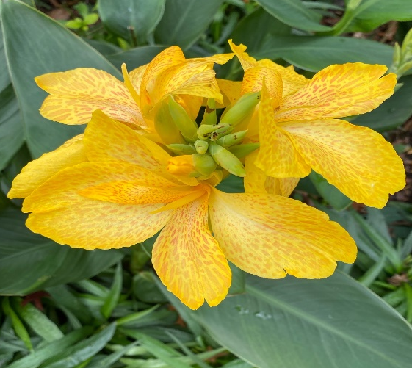
NATURE WALK TIPS
Here are five tips for a great nature walk:
Get outside. Whether in your backyard, a local park, or somewhere else, the first step is to go outdoors.
Be prepared. Bring a container to collect items you find. Bring a camera or a sketchbook. A first aid kit is always a good idea!
Be observant. Use your five senses to experience nature. Document your observations. If you are unsure about something that looks potentially dangerous, do not be afraid to ask for help.
Be Kind. It is important to leave natural places looking better than you found them, so others can enjoy them after you. Throw away trash. Treat plants and animals you find respectfully.
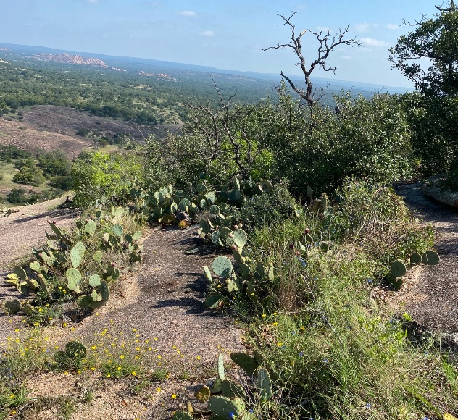
Create. Making art with items you gather from your nature walk is a great way to think outside the box and be resourceful.

